Project Design Phase-II
Technology Stack (Architecture & Stack)

Date | 13 0ctober 2026
Team ID
Project Name | Metro Ticket Generating System in ServiceNow
Maximum Marks | 4 Marks

Technical Architecture:
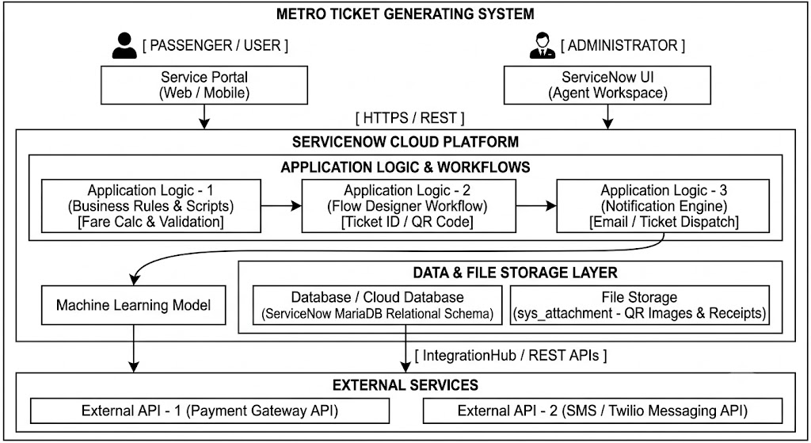

Table-1 : Components & Technologies:
S.No | Component | Description | Technology
 | User Interface | Self-service web portal for passengers to select stations, view route details, choose ticket types, and request metro tickets. | ServiceNow Service Portal (HTML5, CSS3, JavaScript, AngularJS).
 | Application Logic-1 | Core business logic for ticket requests, station route mapping, fare calculation, and ticket status lifecycle management. | ServiceNow Server-Side Scripts (GlideRecord, Script Includes, Business Rules).
 | Application Logic-2 | Automated backend workflow to orchestrate ticket generation, issue unique ticket IDs, generate QR codes, and trigger fulfillment. | ServiceNow Flow Designer / Workflows
 | Application Logic-3 | Automated notification engine to dispatch electronic ticket confirmations and QR details to users. | ServiceNow Notification Engine (Email / SMS Notifications)
 | Database | Structured relational database tables storing ticket transactions, station details, pricing rules, and user records. | ServiceNow System Database (MariaDB-backed relational schema)
 | Cloud Database | Cloud instance storage hosting customer instances and operational data securely. | ServiceNow Advanced High Availability (AHA) Infrastructure / Multi-Instance Cloud
 | File Storage | Storage for exported ticket receipts, generated QR code image blobs, and audit logs. | ServiceNow Attachment Table (sys_attachment)
 | External API-1 | Integration interface for processing metro ticket payments securely via third-party gateways. | REST API / Payment Gateway API (e.g., Razorpay / Stripe via ServiceNow IntegrationHub)
 | External API-2 | SMS/WhatsApp messaging API for sending digital ticket links or QR tickets directly to user mobile devices. | REST API / Twilio Messaging API
 | Machine Learning Model | Smart service assistant/Virtual Agent to assist users with ticket queries, refunds, and route selection. | ServiceNow Predictive Intelligence / Virtual Agent (NLU)
 | Infrastructure (Server / Cloud) | Cloud-hosted platform instance provided as SaaS. | Local Server Configuration: N/A (Cloud-based platform)  Cloud Server Configuration: ServiceNow SaaS (Developer Personal Developer Instance / Enterprise Cloud).

Table-2: Application Characteristics:
S.No | Characteristics | Description | Technology
 | Open-Source Frameworks | Web components and client-side UI scripting framework used in Service Portal widgets. | AngularJS, Bootstrap, HTML5/CSS3
 | Security Implementations | Access control rules, role-based user permissions (e.g., Admin, Passenger, Ticket Verifier), and encrypted data transmission. | Access Control Lists (ACLs), ServiceNow Data Encryption, TLS 1.3, HTTPS, IAM Roles
 | Scalable Architecture | Cloud multi-instance architecture separating UI, application logic, and database layer for high throughput. | ServiceNow Multi-Instance SaaS Platform / 3-Tier Enterprise Architecture
 | Availability | Multi-region data redundancy, automated failover, and high availability setup ensuring round-the-clock access. | ServiceNow Advanced High Availability (AHA) Architecture & Load Balancers
 | Performance | Performance optimization using browser caching, index tuning, and asynchronous script execution for fast response times. | ServiceNow Caching, Indexing, Asynchronous GlideRecord calls, Service Portal Optimization.

